**Bill of Materials Report Sep 29, 2023**

|  |  |  |  |  |  |  |  |  |  |  |  |  |  |  |  |  |  |  |  |  |  |  |  |  |  |  |  |  |  |  |  |  |  |  |  |  |  |  |  |  |  |  |  |  |  |  |  |  |  |  |  |  |  |  |  |  |  |  |  |  |  |  |
| --- | --- | --- | --- | --- | --- | --- | --- | --- | --- | --- | --- | --- | --- | --- | --- | --- | --- | --- | --- | --- | --- | --- | --- | --- | --- | --- | --- | --- | --- | --- | --- | --- | --- | --- | --- | --- | --- | --- | --- | --- | --- | --- | --- | --- | --- | --- | --- | --- | --- | --- | --- | --- | --- | --- | --- | --- | --- | --- | --- | --- | --- | --- |
| **Heatmap** | |  |  |  |  |  |  |  |  |  |  |  |  |  |  |  |  |  |  |  |  |  |  |  |  |  |  |  |  |  |  |  |  |  |  |  |  |  |  |  |  |  |  |  |  |  |  |  |  |  |  |  |  | | --- | --- | --- | --- | --- | --- | --- | --- | --- | --- | --- | --- | --- | --- | --- | --- | --- | --- | --- | --- | --- | --- | --- | --- | --- | --- | --- | --- | --- | --- | --- | --- | --- | --- | --- | --- | --- | --- | --- | --- | --- | --- | --- | --- | --- | --- | --- | --- | --- | --- | --- | --- | | **-95** |  |  |  |  |  |  |  |  |  |  |  |  |  |  |  |  |  |  |  |  |  |  |  |  |  |  |  |  |  |  |  |  |  |  |  |  |  |  |  |  |  |  |  |  |  |  |  |  |  |  | **-45** | | | | | | | | | | |
| **Data-Rates** |  | **1.3Gb** |  | **850Mb** |  | **450Mb** |  | **300Mb** |  | **108Mb** |  | **54Mb** |

**Campus: default__43a04e22338e11ed92dbc6a474cf6c78**

Data Rate : N/A

Client Xmit : 30

**Building: MainCampus**

Address : 6280 America Center Dr

Data Rate : 36

Client Xmit : 30

Geo Code : Long: -121.9788586 Lat: 37.4192348

**Floor 1.0: FNX1stfloor**

Environment : Offices

Data Rate : 36.0 Mbps

Client Xmit : 30

Floor Height : 10.00 Meters

Image Area : 640 Sq Meters

Total Controllers : 0

Total IDFs : 0

Total Racks : 0

Total Switches : 0

Total Ports : 0

Total POE Ports : 0

Total APs : 1

Total AMs : 1

**Floor Plan Only View**

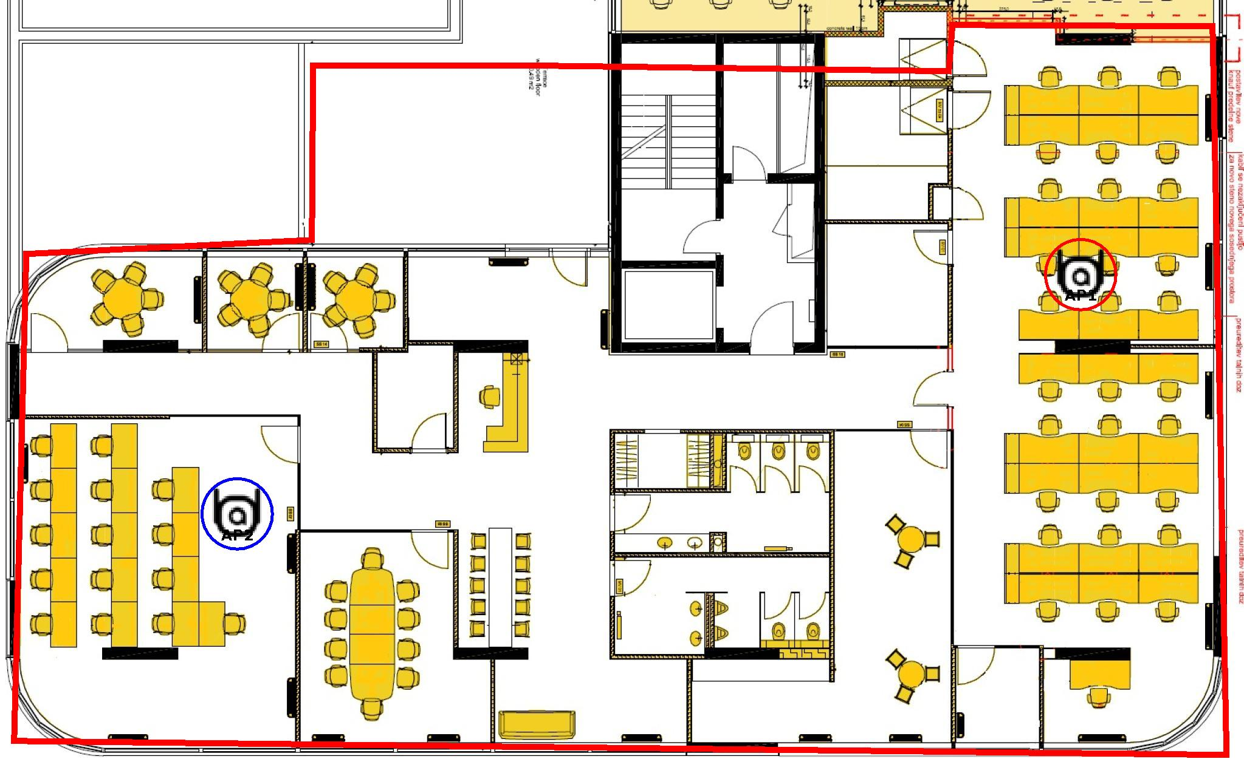

**Data Rate View**

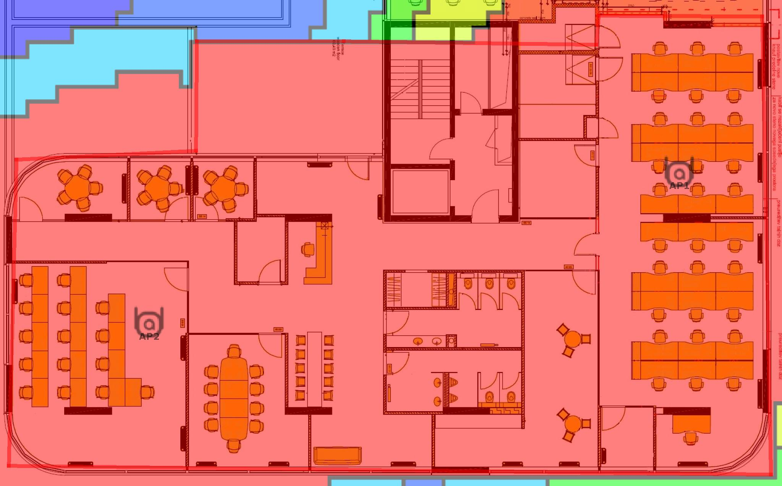

**Heat Map View**

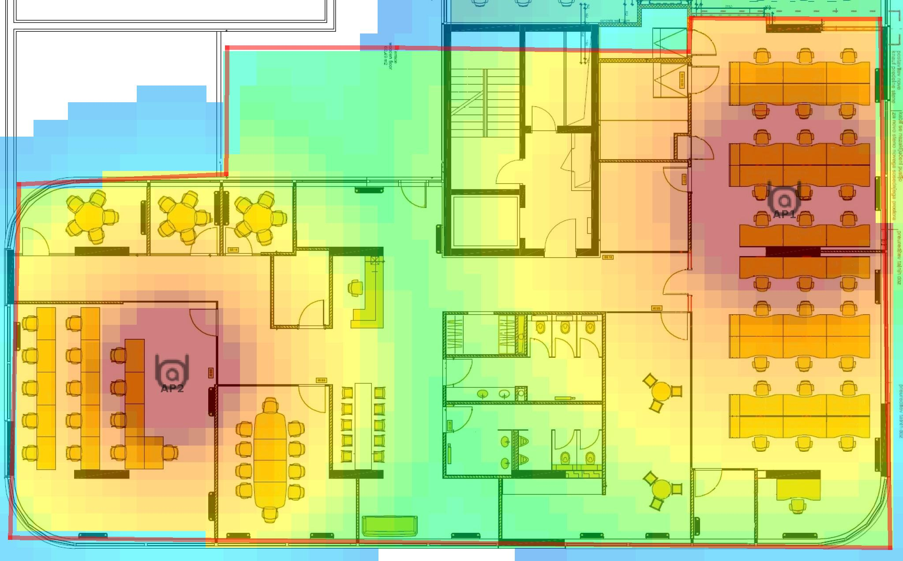

|  |  |  |  |  |  |  |  |  |  |
| --- | --- | --- | --- | --- | --- | --- | --- | --- | --- |
| AP Inventory | | | | | | | | | |
| **Name** | **Model** | **Part #** | **PHY** | **Ch** | **Xmit dBm** | **Ga in dBm** | **LAN MAC** | **Switch** | **Port** |
| AP2 | Aruba AP 505H | AP-505H | 802.11ax(5.0)  802.11n(2.4) | 100  - | 12.0  12.0 | 2.7  2.7 | 28:DE:65:11:8E:27 |  |  |
| AP1 | Aruba AP 505H | AP-505H | 802.11n(2.4)  802.11ac(5.0) | 6  140 | 9.0  18.0 | 2.7  2.7 | 28:DE:65:11:96:65 |  |  |

|  |  |  |  |  |  |  |  |  |  |
| --- | --- | --- | --- | --- | --- | --- | --- | --- | --- |
| Wired Inventory | | | | | | | | | |
| **Name** | **Model** | **Part #** | **# POE Ports** | **Total Ports** | **IDF** | **Rack** | **Rack Unit #** |

|  |  |  |  |  |  |  |  |  |  |
| --- | --- | --- | --- | --- | --- | --- | --- | --- | --- |
| Floor Total | | | | | | | | | |
| **Part #** | **Type** | **Mode** | **Qty** |
| AP-505H | Aruba AP 505H | AP  AM | 1  1 |

|  |  |  |  |  |  |  |  |  |  |
| --- | --- | --- | --- | --- | --- | --- | --- | --- | --- |
| Summary | | | | | | | | | |
| **Part #** | **Type** | **Mode** | **Qty** |
| AP-505H | Aruba AP 505H | AP  AM | 1  1 |